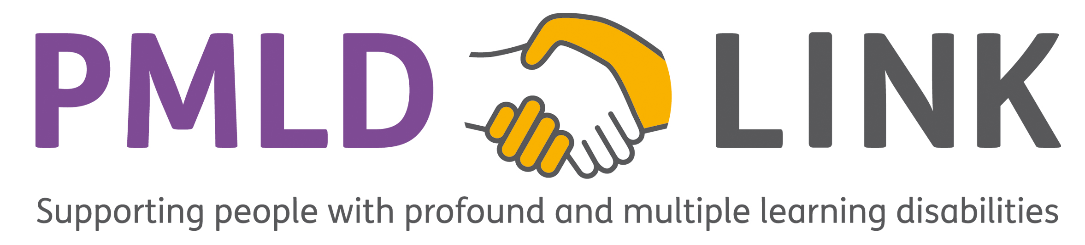

Use of Image Consent Form

Before completing this form, please read the Mencap guidelines ‘Consent for videos and photos of people with PMLD’ (available from the PMLD Link website at http://www.pmldlink.org.uk/get-involved).

We keep securely the image(s) and other information that you give. These will not be given or sold to other people or organisations. The image(s) will be solely used, as agreed by you, in one or more of the following: (a) the published PMLD LINK journal (which will be available as a hard copy or online via the PMLD LINK website); (b) the PMLD LINK website; (c) on the PMLD LINK Facebook page; and/or (d) in occasional PMLD LINK publicity material (e.g. in a newsletter or conference handout). After three years we will seek your permission again if we wish to reuse the image(s).

Insert copy of image(s)

To: PMLD Link

We are happy for PMLD Link to use the above image(s) in the following places (please mark with a X those places where you are happy for the image(s) to appear):

- In the PMLD Link Journal

- On the PMLD Link website

- On the PMLD LINK Facebook page

- In PMLD Link publicity material

Do you have any other comments about the use of the image(s) including any limitations?

Name of person in image(s)

Name and relationship of person filling out form (if not person in image(s))

Signature of person filling out form (relative or guardian must sign if person is under 18)

Contact Address inc. Postcode:

Email:

Tel:

Additional signatures and relationships; (e.g. relative, carer, friend, advocate)

Please send this form with the image(s) to:

Rob Ashdown, PMLD LINK Treasurer, 15 Cliff Gardens, Scunthorpe, North Lincolnshire, DN15 7PH

or

e-mail to info@pmldlink.org.uk

Thank you

